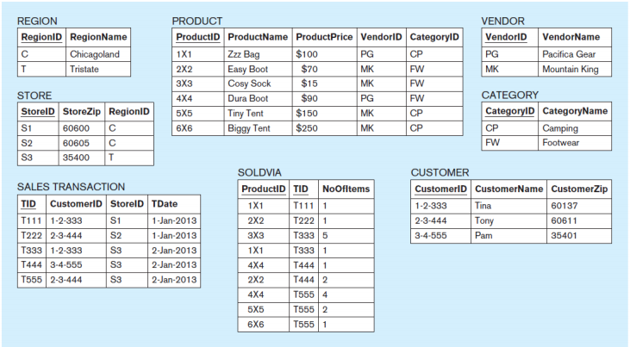

1.1 SELECT *

FROM REGION;

1.2 SELECT S.StoreID, S.StoreZip

FROM STORE AS S;

1.3 SELECT C.CustomerName, C.CustomerZip

FROM CUSTOMER AS C

ORDER BY C.CustomerName ASC;

1.4 SELECT DISTINCT S.RegionID

FROM STORE AS S;

1.5 SELECT *

FROM STORE

WHERE RegionID = ‘C’;

1.6 SELECT C.CustomerID, C.CustomerName

FROM CUSTOMER AS C

WHERE CustomerName = ‘T*’;

1.7 SELECT P.ProductID, P.ProductName, P.ProductPrice

FROM PRODUCT AS P

WHERE ProductPrice >= $100;

1.8 SELECT P.ProductID, P.ProductName, ProductPrice, V.VendorName

FROM PRODUCT AS P

INNER JOIN VENDOR as V

ON P.venderID = V.VendorID

ORDER BY P.ProductID ASC;

1.9 SELECT P.ProductID, P.ProductName, ProductPrice, V.VendorName, C.CategoryName

FROM PRODUCT AS P

INNER JOIN VENDOR AS V

ON P.VendorID = V.VendorID

INNER JOIN CATEGORY AS C

ON P.categoryID = C.CategoryID

ORDER BY P.ProductID ASC;

1.10 SELECT P.ProductID, P.ProductName, P.ProductPrice

FROM PRODUCT AS P, Category AS C

WHERE P.CategoryID = C.CategoryID and CategoryName = ‘Camping’

ORDER BY P.productID ASC;

1.11 SELECT P.ProudctID, P.ProductName, P.ProductPrice

FROM PRODUCT AS P, SOLDVIA AS SO, SALESTRANSACTION AS ST, STORE AS S

WHERE P.ProductID = SO.ProductID

AND SO.TID = ST.TID

AND ST.StoreID = S.StoreID

AND S.StoreZip = ‘60600’

ORDER BY P.ProductID ASC;

1.12 SELECT P.ProudctID, P.ProductName, P.ProductPrice

FROM PRODUCT AS P, SOLDVIA AS SO, SALESTRANSACTION AS ST, STORE AS S, REGION AS R, VENDOR AS V

WHERE P.ProductID = SO.ProductID

AND SO.TID = ST.TID

AND ST.StoreID = S.StoreID

AND S.RegionID = R.RegionID

AND V.VendorName = ‘Pacific Gear’

And R.RegionName = ‘Tristate’

ORDER BY P.ProductID ASC;

1.13 SELECT ST.TID, C.CustomerName, ST.TDate

FROM SALESTRANSCATION AS ST, PRODUCT AS P, SOLDIVIA AS SO, CUSTOMER AS C

WHERE C.CustomerID = ST.CustomerID

AND ST.TID = SO.TID

AND SO.ProductID = P.ProductID

AND P.ProductID = ‘Easy Boot’;

1.14 SELECT R.RegionID, R.RegionName, COUNT(S.STOREID) = NUM_STORES

FROM Region AS R, Store As S

WHERE R.RegionID = S.RegionID;

1.15 SELECT C.CATEGORYID, C.CATEGORYNAME, AVG(P.PRODUCTPRICE) = AVG_PRICE

FROM CATEGORY AS C

JOIN PRODUCT AS P

ON C.CATEGORYID = P.CATEGORYID;

1.16 SELECT P.CATEGORYID, SUM(SO.NoOfItems) = NMBR_OF_ITEMS_PURCHASED_IN_CAT

FROM PRODUCT AS P, CATEGORY AS C

FROM PRODUCT AS P

JOIN SOLDVIA AS S

ON P.ProductID = S.ProductID;

1.17 SELECT R.RegionID, R.RegionName, SUM(P.Productprice*SO.NoOFItems) = Amount_Spend

FROM PRODUCT AS P, SOLDVIA AS SO, SALESTRANSCATION AS ST, STORE AS S, REGION AS R

WHERE P.ProductID= SO.ProductID

AND SO.TID = ST.TID

AND ST.StoreID = S.StoreID

AND S.RegiondID = R.RegionID;

1.18 SELECT SO.TID, sum(SO.NoOFItems)

FROM SOLDVIA AS SO

HAVING SUM(SO.NoOFItems) > 5;

1.19 SELECT V.vendorid, V.vendorname, (P.Productprice * SO.NoOFItems) = Total_Sales

FROM VENDOR AS V, SOLDVIA SO, PRODUCT AS P

WHERE Total_Sales > 700;

1.20 SELECT P.ProductID,P.ProductName, P.ProductPrice

FROM PRODUCT AS P

WHERE P.ProductPrice = (SELECT MIN(P.ProductPrice) FROM P);

1.21 SELECT P.ProductID, P.ProductName,V.VendorName

FROM PRODUCT AS P, VENDOR AS V

WHERE P.ProductPrice < (SELECT AVG(P.PRoductPrice) FROM P);

1.22 SELECT P.PRODUCTID, P.PRODUCTNAME  
FROM PRODUCT AS P, SOLDVIA AS SO  
WHERE P.PRODUCTID = SO.PRODUCTID   
GROUP BY PRODUCTID  
HAVING SUM(NUMOFITEMS) > 2;

1.23 SELECT P.PRODUCTID

FROM SOLDVIA AS S, PRODUCT AS P

GROUP BY P.PRODUCTID

HAVING SUM(SO.NoOFItems) = (SELECT MAX(SUM(SO.NoOfItems))

1.24 SELECT P.ProductID, P.ProductName, P.ProductPrice

FROM PRODUCT AS P, SOLDVIA AS SO

WHERE P.ProductID = SO.ProductID

GROUP BY SO.ProductID

HAVING SUM(SO.NoOfItems)>3;

1.25 SELECT P.ProductID, P.ProductName, P.ProductPrice

FROM Product AS P, SOLDVIA AS SO

WHERE P.ProductID=SO.ProductID

GROUP BY SO.ProductID

HAVING COUNT(SO.TID)>1;